

**Amazon Sales Data Report**

*Prepared in the partial fulfilment of the Data Analytics in* ***InnoByte*** *Service Internship Program*

*Under the Guidance of*

Mrs. Sonali Agarwal

Talent Acquisition Team (InnoByte)

*Submitted by*

Chinta Bala sai reddy-22PA1A4525

FROM:

VISHNU INSTITUTE OF TECHNOLOGY(VITB)

**Problem Statement**

Analyze and Provide Insights on Amazon Sales Report

**Problem Description**

The provided dataset contains information about sales transactions on Amazon, including details such as order ID, date, status, fulfilment method, sales channel, product category, size, quantity, amount, shipping details, and more. The objective is to conduct a comprehensive analysis of the data and extract actionable insights to support business decision-making.

Datasets[: Amazon Sales Dataset](https://drive.google.com/file/d/1YrjYKtS1WHmINL6eafRsrDzrZaw2_WvX/view)

**Pre-Processing Steps:**

1. **Data Transformation:**
   * Used Power BI Desktop to transform the data.
   * Set the first row as column headers.
2. **Handling Duplicates:**
   * Checked for duplicates in the Order ID column and removed them.
3. **Data Quality Checks:**
   * Used Show Whitespace, Column Quality, and Column Distribution to analyze errors, empty values, and valid percentages in the data.
4. **Data Type Detection:**
   * Used auto data type detection in the Transform tab to ensure correct column types.
5. **Replacing Empty Values:**
   * Replaced empty values in numerical columns with 0.
   * Replaced empty values in categorical columns with nan**.**
6. **Column Deletion:**
   * Deleted two entirely empty columns: [New] and [PendingS].
7. **Date Column Issue:**
   * The Date column was incorrectly detected as an Indian data type. You solved this by right-clicking on the column and using Change Type > Using Locale to change the locale from "English India" to "English United States," which enabled Power BI to correctly recognize the column as a date.
8. **Correcting the Amount Column:**
   * Detected that the Amount column was incorrect due to the presence of cancelled product amounts. Used a DAX formula to create a new column [Correct Amount].
9. **Calculations Using DAX:**
   * Calculated the average amount per product/category.
   * Calculated cancellation rate.
   * Calculated success rate.
   * Calculated MoM% (Month over Month Percentage) using the [Correct Amount] column.

**Report Creation:**

**You created three report pages:**

1. **Category/Product Analysis:**
   * Used Cards, Donut Charts, Line Chart, Clustered Bar Chart, and Slices.
   * Applied a dark theme for the product/category analysis.
2. **Customer Behaviour Analysis:**
   * Used Donut Charts, Slices, Cards, Multi-row Card, Stacked Column Chart, and Line Chart.
   * Applied a dark theme.
3. **Geographical Analysis:**
   * Used Cards, Multi-row Card, Map, Matrix Table, and Slices.

**Tools and Visualizations:**

* You effectively utilized Power BI’s visualizations such as cards, charts, and tables to represent the data and insights.
* You applied a dark theme for the product/category analysis and customer behavior analysis to maintain consistency and readability in your reports.

This comprehensive process demonstrates a solid understanding of both data preprocessing and visualization using Power BI.

**Key Objectives**

1. **Sales Overview**: Understand the overall sales performance, trends, and patterns over time.
2. **Product Analysis**: Analyze the distribution of product categories, sizes, and quantities sold to identify popular products.
3. **Fulfillment Analysis**: Investigate the fulfillment methods used and their effectiveness in delivering orders.
4. **Customer Segmentation**: Segment customers based on their buying behavior, location, and other relevant factors.
5. **Geographical Analysis**: Explore the geographical distribution of sales, focusing on states and cities.
6. **Business Insights**: Provide actionable insights and recommendations to optimize sales strategies, improve customer satisfaction, and enhance overall business performance.

**Deliverables**

1. Comprehensive analysis report summarizing key findings, insights, and recommendations.
2. Visualizations (charts, graphs) illustrating various aspects of the data analysis.
3. Insights on product preferences, customer behavior, and geographical sales distribution.
4. Recommendations for improving sales strategies, inventory management, and customer service.

**Expected Outcome**

By conducting a thorough analysis of the Amazon sales report, the goal is to gain valuable insights that can be leveraged to optimize business operations, enhance customer experience, and drive revenue growth. The analysis should provide actionable recommendations tailored to the specific needs and challenges of the business.

**Analysis and Findings**

1. **Sales Overview**:
   * Identified trends in monthly and seasonal sales performance.
   * Determined peak sales periods and factors contributing to variations.
2. **Product Analysis**:
   * Highlighted top-selling product categories and sizes.
   * Analyzed the quantity sold to determine popular products and inventory demand.
3. **Fulfilment Analysis**:
   * Evaluated the effectiveness of different fulfilment methods.
   * Identified delays and inefficiencies impacting customer satisfaction.
4. **Customer Segmentation**:
   * Categorized customers based on purchasing behaviour and location.
   * Identified high-value customer segments for targeted marketing.
5. **Geographical Analysis**:
   * Mapped sales distribution across states and cities.
   * Identified regions with high sales potential for future investments.

**Business Insights and Recommendations**

1. **Sales Strategies**:
   * Focus marketing campaigns on high-performing regions and product categories.
   * Leverage data on peak sales periods to optimize promotional efforts.
2. **Inventory Management**:
   * Maintain optimal stock levels for high-demand products.
   * Use predictive analytics to forecast inventory needs based on sales trends.
3. **Customer Service Improvements**:
   * Enhance communication about delivery status and offer flexible return policies.
   * Introduce loyalty programs to reward repeat customers and build long-term relationships.
4. **Fulfilment Optimization**:
   * Streamline delivery processes to reduce delays.
   * Partner with reliable logistics providers and implement real-time tracking systems.
5. **Geographical Focus**:
   * Expand operations in regions with untapped potential.
   * Tailor product offerings to regional preferences.

**Visualizations**

Visual representations such as sales trend graphs, product distribution charts, and geographical heatmaps accompany this report to provide deeper insights. These can be accessed in the accompanying Power BIdashboard or the detailed appendix

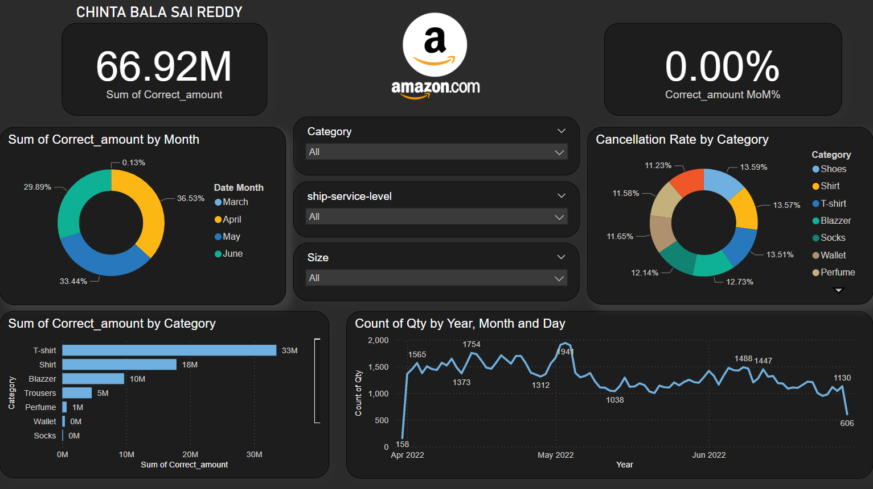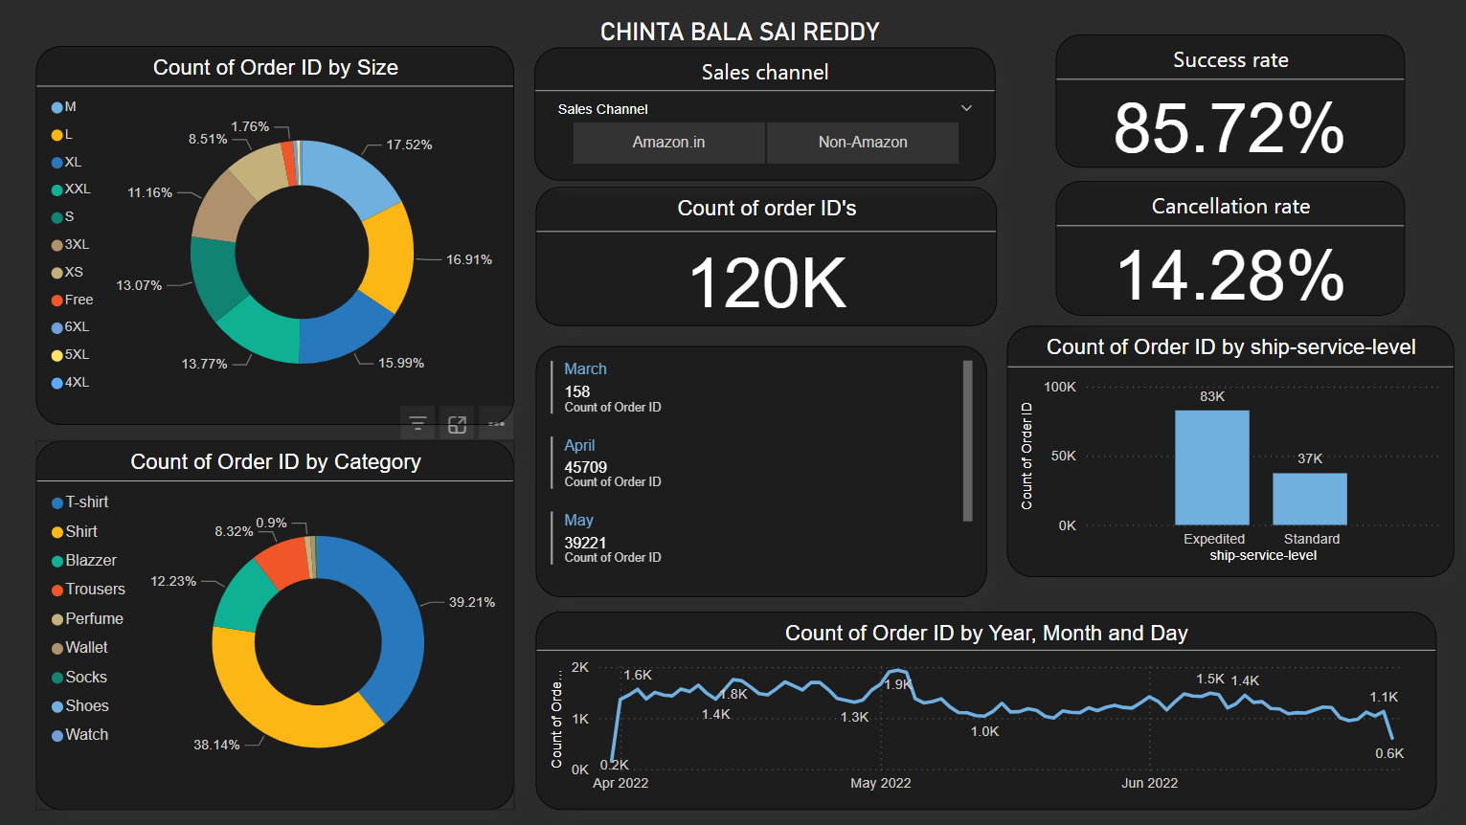

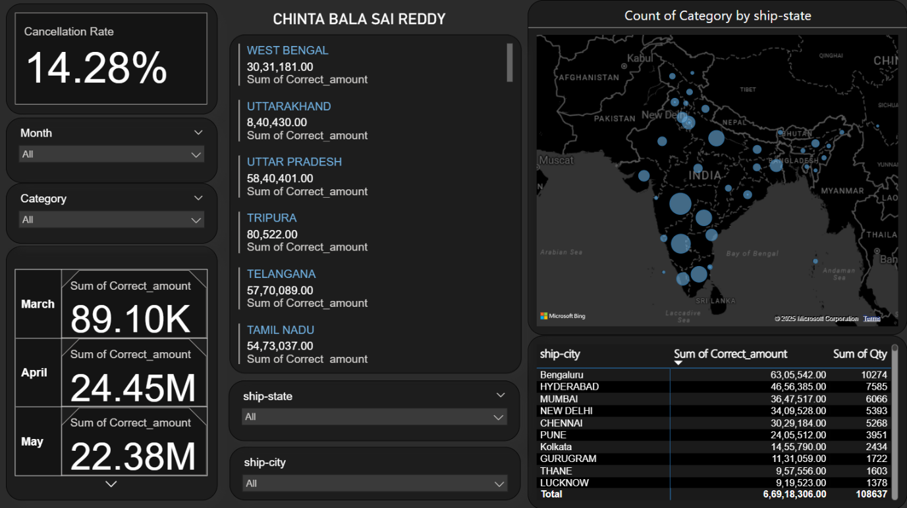

**Conclusion**

This comprehensive analysis of Amazon's sales data provides actionable insights to optimize sales strategies, improve customer satisfaction, and enhance overall business performance. By implementing the recommendations, Amazon can achieve sustainable growth and maintain a competitive edge in the market.